Functional Electronic Circuits Lab4

Student Name: CAO Xinyang

Student ID: 20321308

**1. The picture of the system**

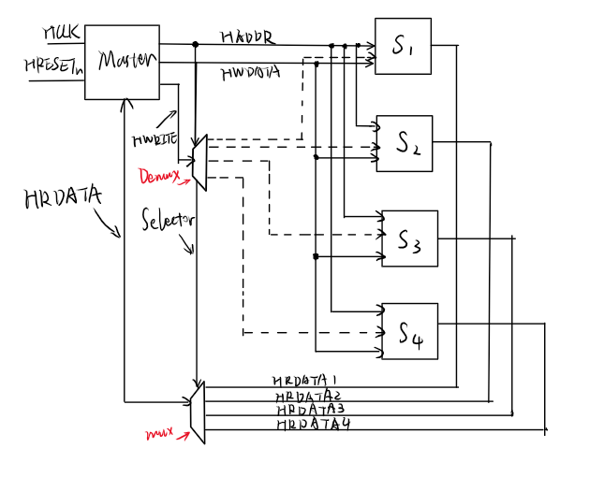

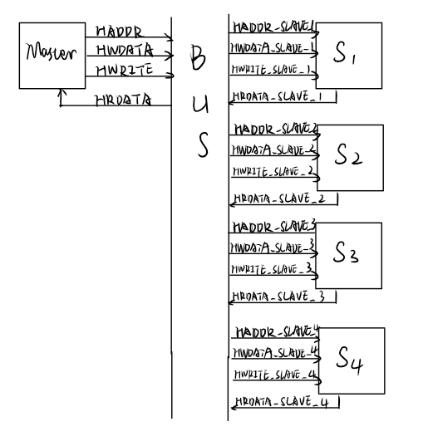

**2. The timing diagram with simulation results**

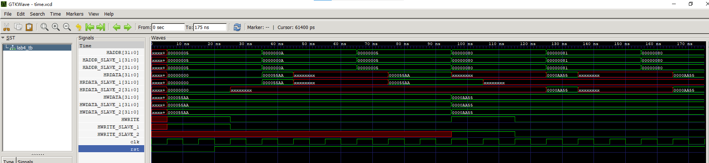

**3. Code of the testbench and the device**

***busDevice.v***

module bus(

    input [31:0] HADDR_MASTER_bi,

    input [31:0] HWDATA_MASTER_bi,

    input HWRITE_MASTER_i,

    output reg [31:0] HRDATA_MASTER_bo,

    output [31:0] HADDR_SLAVE_1_bo,

    output [31:0] HWDATA_SLAVE_1_bo,

    output reg HWRITE_SLAVE_1_o,

    input [31:0] HRDATA_SLAVE_1_bi,

    output [31:0] HADDR_SLAVE_2_bo,

    output [31:0] HWDATA_SLAVE_2_bo,

    output reg HWRITE_SLAVE_2_o,

    input [31:0] HRDATA_SLAVE_2_bi

);

assign HADDR_SLAVE_1_bo = HADDR_MASTER_bi;

assign HADDR_SLAVE_2_bo = HADDR_MASTER_bi;

assign HWDATA_SLAVE_1_bo = HWDATA_MASTER_bi;

assign HWDATA_SLAVE_2_bo = HWDATA_MASTER_bi;

always@*

    if (HADDR_MASTER_bi < 32'h80) begin

        HWRITE_SLAVE_1_o <= HWRITE_MASTER_i;

        HRDATA_MASTER_bo <= HRDATA_SLAVE_1_bi;

    end else begin

        HWRITE_SLAVE_2_o <= HWRITE_MASTER_i;

        HRDATA_MASTER_bo <= HRDATA_SLAVE_2_bi;

    end

endmodule

***masterDevice.v***

module master(

    input HCLK_i,

    input HRESETn_i,

    input [31:0] HRDATA_bi,

    output reg [31:0] HADDR_bo,

    output reg [31:0] HWDATA_bo,

    output reg HWRITE_o

);

task write(

    input [31:0] addr,

    input [31:0] data

);

    begin

        @(posedge HCLK_i);

        HADDR_bo <= addr;

        HWRITE_o <= 1;

        HWDATA_bo <= data;

        @(posedge HCLK_i);

        @(posedge HCLK_i);

        HWRITE_o <= 0;

    end

endtask

task read(

    input [31:0] addr

);

    begin

        @(posedge HCLK_i);

        HADDR_bo <= addr;

        HWRITE_o <= 0;

        @(posedge HCLK_i);

        @(posedge HCLK_i);

        $display("READ DATA | addr: %h, data: %h", addr, HRDATA_bi);

    end

endtask

initial begin

    write(32'h5, 32'h55AA);

    read(32'hA);

    read(32'h5);

    write(32'h80, 32'hAA55);

    read(32'h81);

    read(32'h80);

    $finish;

end

endmodule

***slaveDevice.v***

module slave(

    input HCLK_i,

    input HRESETn_i,

    output reg [31:0] HRDATA_bo,

    input [31:0] HADDR_bi,

    input [31:0] HWDATA_bi,

    input HWRITE_i

);

reg [31:0] mem [255:0];

always@(posedge HCLK_i)

    if (HRESETn_i == 0)

        HRDATA_bo <= 0;

    else begin

        if (HWRITE_i)

            mem[HADDR_bi] <= HWDATA_bi;

        else

            HRDATA_bo <= mem[HADDR_bi];

    end

endmodule

***testBench.v***

`timescale 1ns/1ps

module lab4_tb;

reg clk, rst;

wire [31:0] HRDATA, HADDR, HWDATA;

wire HWRITE;

wire [31:0] HRDATA_SLAVE_1, HADDR_SLAVE_1, HWDATA_SLAVE_1;

wire HWRITE_SLAVE_1;

wire [31:0] HRDATA_SLAVE_2, HADDR_SLAVE_2, HWDATA_SLAVE_2;

wire HWRITE_SLAVE_2;

bus buut (

    .HADDR_MASTER_bi(HADDR),

    .HWDATA_MASTER_bi(HWDATA),

    .HRDATA_MASTER_bo(HRDATA),

    .HWRITE_MASTER_i(HWRITE),

    .HADDR_SLAVE_1_bo(HADDR_SLAVE_1),

    .HWDATA_SLAVE_1_bo(HWDATA_SLAVE_1),

    .HRDATA_SLAVE_1_bi(HRDATA_SLAVE_1),

    .HWRITE_SLAVE_1_o(HWRITE_SLAVE_1),

    .HADDR_SLAVE_2_bo(HADDR_SLAVE_2),

    .HWDATA_SLAVE_2_bo(HWDATA_SLAVE_2),

    .HRDATA_SLAVE_2_bi(HRDATA_SLAVE_2),

    .HWRITE_SLAVE_2_o(HWRITE_SLAVE_2)

);

master muut(

    .HCLK_i(clk),

    .HRESETn_i(rst),

    .HRDATA_bi(HRDATA),

    .HADDR_bo(HADDR),

    .HWDATA_bo(HWDATA),

    .HWRITE_o(HWRITE)

);

slave suut1(

    .HCLK_i(clk),

    .HRESETn_i(rst),

    .HRDATA_bo(HRDATA_SLAVE_1),

    .HADDR_bi(HADDR_SLAVE_1),

    .HWDATA_bi(HWDATA_SLAVE_1),

    .HWRITE_i(HWRITE_SLAVE_1)

);

slave suut2(

    .HCLK_i(clk),

    .HRESETn_i(rst),

    .HRDATA_bo(HRDATA_SLAVE_2),

    .HADDR_bi(HADDR_SLAVE_2),

    .HWDATA_bi(HWDATA_SLAVE_2),

    .HWRITE_i(HWRITE_SLAVE_2)

);

always #5 clk = ~clk;

initial begin

    $dumpfile("time.vcd");

    $dumpvars(1, lab4_tb);

    clk = 0;

    rst = 0;

    #20

    rst = 1;

end

endmodule